[ Problem View ]
Magnetic Field near a Moving Charge
Description: Use Biot-Savart law to find the magnetic field at various points due to a charge moving along the z axis.
A particle with positive charge is moving with speed along the z axis toward positive . At the time of this problem it is located at the origin, . Your task is to find the magnetic field at various locations in the three-dimensional space around the moving charge. 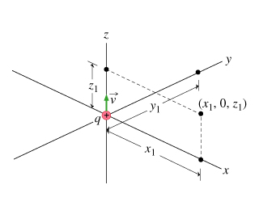
Part A
Which of the following expressions gives the magnetic field at the point due to the moving charge?
A. 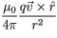
B. 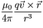
C. 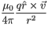
D. 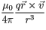
ANSWER:
  Top of Form  Bottom of Form | A onlyB onlyC onlyD only  both A and Bboth C and Dboth A and Cboth B and D
The main point here is that the r-dependence is really . The results from using in the numerator rather than the unit vector .
A second point is that the order of the cross product must be such that the right-hand rule works: If your right thumb is along the direction of the current, , your fingers must curl along the direction of the magnetic field.

Part B
Find the magnetic field at the point .
Part B.1
Part not displayed
Express your answer in terms of , , , and , and use , , and for the three unit vectors.
ANSWER:
   | = | (mu_0/(4*pi))*(q*v/x_1^2)*y_unit

Part C
Find the magnetic field at the point .
Express your answer in terms of , , , , and , and use , , and for the three unit vectors.
ANSWER:
   | = | -(mu_0/(4*pi))*(q*v /y_1^2)*x_unit

Part D
Find the magnetic field at the point .
Part D.1 | Evaluate the cross product
To find the magnetic field for this part, it is convenient to use expression B from Part A:
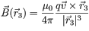.
Knowing and , find .
Express your answer in terms of given quantities and , , and/or .
ANSWER:
   | = | v*x1*y_unit

Part D.2 | Find the distance from the charge
Part not displayed
Express your answer in terms of , , , , , and , and use , , and for the three unit vectors.
ANSWER:
   | = | (mu_0/(4*pi))*(q*v*x_1/(x_1^2 + z_1^2)^(3/2))*y_unit

Part E
The field found in this problem for a moving charge is the same as the field from a current element of length carrying current provided that the quantity is replaced by which quantity?
Hint E.1
Hint not displayed

ANSWER:
  i*dl

[ Print ]

[ Problem View ]
Magnetic Field from Current Segments
Description: Magnetic field calculations for z-axis as a function of currents in xy plane.
Learning Goal: To apply the Biot-Savart law to find the magnetic field produced on the z axis from current elements in the xy plane.
In this problem you are to find the magnetic field component along the z axis that results from various current elements in the xy plane (i.e., at ).
The field at a point due to a current-carrying wire is given by the Biot-Savart law,
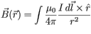,
where and , and the integral is done over the current-carrying wire. Evaluating the vector integral will typically involve the following steps:
- Choose a convenient coordinate system--typically rectangular, say with coordinate axes , , and .
- Write in terms of the coordinate variables and directions ( , , etc.). To do this, you must find and . Again, finding the cross product can be done either
  - geometrically (by finding the direction of the cross product vector first, then checking for cancellations from any other portion of the wire, and then finding the magnitude or relevant component) or
  - algebraically (by using , etc.).
- Evaluate the integral for the component(s) of interest.
In this problem, you will focus on the second of these steps and find the integrand for several different current elements. You may use either of the two methods suggested for doing this.
Part A
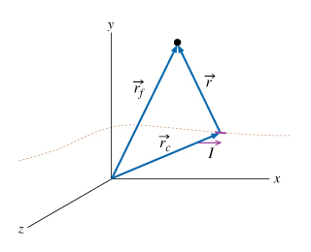The field at the point shown in the figure due to a single current element is given by
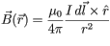,
where and . In this expression, what is the variable ?
Hint A.1 | Making sense of subscripts
- points from the origin to the point where you want to find the magnetic field.
- points from the origin to the current element in question.
- points from the current element to the point where you want to find the magnetic field.

ANSWER:
  Top of Form
  Bottom of Form

Part B
Find , the z component of the magnetic field at the point from the current flowing over a short distance located at the point . 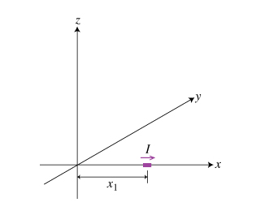
Hint B.1 | Cross product
The key here is the cross product in the Biot-Savart law. What is the cross product when and are parallel?
Express your answer in terms of , , , , , and the unit vectors , , and/or .
ANSWER:
   | = | 0

Part C
Find , the z component of the magnetic field at the point from the current flowing over a short distance located at the point . 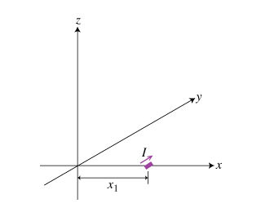
Part C.1 | Determine the displacement from the current element
What is , the distance (magnitude) from the current element to the point in question?
ANSWER:
   | = | x_1

Part C.2 | Find the direction from the cross product
What is the unit vector that describes the direction of the magnetic field at the origin ?
Express your answer in terms of , , or .
ANSWER:
  z_unit

Express your answer in terms of , , , , , and the unit vectors , , and/or .
ANSWER:
   | = | (mu_0)/(4*pi) *I*dl /x_1^2  (mu_0)/(4*pi) *I*dl /x_1^2*z_unit

Part D
Find , the z component of the magnetic field at the point P located at from the current flowing over a short distance located at the point . 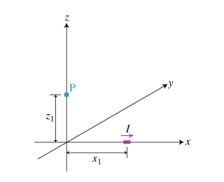
Part D.1 | Determine the displacement from the current element
Part not displayed

Part D.2 | Use the cross product to get the direction
Part not displayed
Express your answer in terms of , , , , , , and the unit vectors , , and/or .
ANSWER:
   | = | 0

Part E
Find , the z component of the magnetic field at the point from the current flowing over a short distance located at the point . 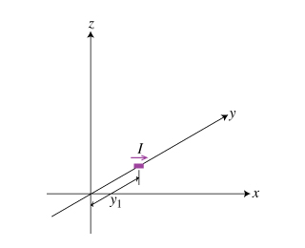
Part E.1 | Determine the displacement from the current element
Part not displayed

Part E.2 | Find the direction of the magnetic field vector
Part not displayed
Express your answer in terms of , , , , , and the unit vectors , , and/or .
ANSWER:
   | = | -mu_0 * I * dl / (4 * pi * y_1^2)  -mu_0 * I * dl / (4 * pi * y_1^2)* z_unit

Part F
Find , the z component of the magnetic field at the point P located at from the current flowing over a short distance located at the point . 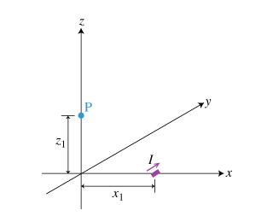
Part F.1 | Determine the displacement from the current element
What is , the displacement (magnitude) from the current element to the point in question? The figure shows another perspective of the same situation to make this calculation easier.
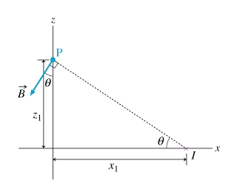
ANSWER:
   | = | sqrt(x_1^2 + z_1^2)

Part F.2 | Determine which unit vector to use
Another way to write the Biot-Savart law is
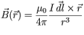,
where you replace with . This eliminates the problem of finding and can make computation easier.
You are asked for the z component of the magnetic field. points in the direction. Which component ( , , or ) must you cross with to get a vector in the z direction? Recall that .
Express your answer in terms of , , or (ignoring the sign).
ANSWER:
  x_unit

Part F.3 | Evaluate the cross product
So, the z component of the magnetic field results from the cross product of and the x component of . These two vectors are orthogonal, so finding the cross product is relatively straightforward. What is the value of ?
Give your answer in terms of , , , and .
ANSWER:
   | = | dl * x_1 * z_unit
Substitute this expression into the formula for the magnetic field given in the last hint. Observe that it has in the denominator since in the original equation was replaced with in the numerator.
Express your answer in terms of , , , , , , and the unit vectors , , and/or .
ANSWER:
   | = | mu_0 * dl / (4 * pi) * I * x_1 / (x_1^2 + z_1^2)^(3/2)  mu_0 * dl / (4 * pi) * I * x_1 / (x_1^2 + z_1^2)^(3/2)*z_unit

[ Print ]

Force...
=(I_1*I_2*mu_0*a^2)/(2*pi*(d^2-a^2/4))
=(m*I_2*mu_0)/(2*pi*(d^2-a^2/4))

[ Problem View ]
Magnetic Field inside a Very Long Solenoid
Description: Leads through steps of using Ampere's law to find field inside solenoid a long solenoid.
Learning Goal: To apply Ampère's law to find the magnetic field inside an infinite solenoid.
In this problem we will apply Ampère's law, written
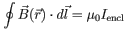,
to calculate the magnetic field inside a very long solenoid. The solenoid has length , diameter , and turns per unit length with each carrying current . 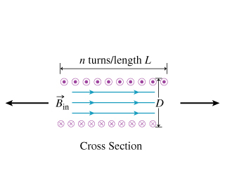It is usual to assume that the component of the current along the z axis is negligible. (This may be assured by winding two layers of closely spaced wires that spiral in opposite directions.)
From symmetry considerations it is possible to show that far from the ends of the solenoid, the magnetic field is axial.
Part A
Which figure shows the loop that the must be used as the Ampèrean loop for finding for inside the solenoid? 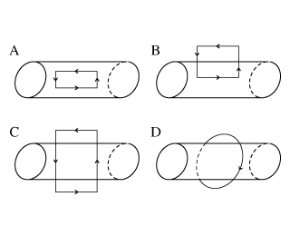
Part A.1 | Choice of path for loop integral
Which of the following choices are a requirement of the Ampèrean loop that would allow you to use Ampère's law to find ?
- The path must pass through the point .
- The path must have enough symmetry so that is constant along large parts of it.
- The path must be a circle.
ANSWER:
  Top of Form  Bottom of Form | a onlya and ba and cb and c
If possible, choose the loop so that the desired field component runs parallel to the loop and other sides of the loop have zero field component along them.

ANSWER:
  Top of Form  Bottom of Form | ABCD

Part B
Assume that loop B (in the Part B figure) has length along . What is the loop integral in Ampère's law? Assume that the top end of the loop is very far from the solenoid (even though it may not look like it in the figure), so that the field there is assumed to be small and can be ignored.
Express your answer in terms of , , and other quantities given in the introduction.
ANSWER:
   | 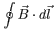 = | B_z(r) * Z_L

Part C
What physical property does the symbol represent?
ANSWER:
  Top of Form  Bottom of Form | The current along the path in the same direction as the magnetic field  The current in the path in the opposite direction from the magnetic field  The total current passing through the Ampèrean loop in either direction  The net current through the Ampèrean loop
The positive direction of the line integral and the positive direction for the current are related by the right-hand rule:
Wrap your right-hand fingers around the closed path, then the direction of your fingers is the positive direction for and the direction of your thumb is the positive direction for the net current.
Note also that the angle the current-carrying wire makes with the surface enclosed by the loop doesn't matter. (If the wire is at an angle, the normal component of the current is decreased, but the area of intersection of the wire and the surface is correspondingly increased.)

Part D
What is , the current passing through the chosen loop?
Express your answer in terms of (the length of the Ampèrean loop along the axis of the solenoid) and other variables given in the introduction.
ANSWER:
   | = | I * n * Z_L

Part E
Find , the z component of the magnetic field inside the solenoid where Ampère's law applies.
Express your answer in terms of , , , , and physical constants such as .
ANSWER:
   | = | mu_0*n*I

Part F
What is , the z component of the magnetic field outside the solenoid?
Part F.1
Part not displayed

ANSWER:
  Top of Form  Bottom of Form | 0

Part G
The magnetic field inside a solenoid can be found exactly using Ampère's law only if the solenoid is infinitely long. Otherwise, the Biot-Savart law must be used to find an exact answer. In practice, the field can be determined with very little error by using Ampère's law, as long as certain conditions hold that make the field similar to that in an infinitely long solenoid.
Which of the following conditions must hold to allow you to use Ampère's law to find a good approximation?
- Consider only locations where the distance from the ends is many times .
- Consider any location inside the solenoid, as long as is much larger than for the solenoid.
- Consider only locations along the axis of the solenoid.

Hint G.1 | Implications of symmetry
Imagine that the the solenoid is made of two equal pieces, one extending from to and the other from to . If both were present the field would have its normal value, but if either is removed the field at drops to one-half of its previous value. This shows that the field drops off significantly near the ends of the solenoid (relative to its value in the middle). However, in doing this calculation, you assumed that the field is constant along the length of the Ampèrean loop. So where would this assumption break down?

Hint G.2 | Off-axis field dependence
You also used symmetry considerations to say that the magnetic field is purely axial. Where would this symmetry argument not hold?
Note that far from the ends there cannot be a radial field, because it would imply a nonzero magnetic charge along the axis of the cylinder and no magnetic charges are known to exist (Gauss's Law for magnetic fields and charges). In conjunction with Ampère's law, this allows us to conclude that the z component of the field cannot depend on inside the solenoid.

ANSWER:
  Top of Form  Bottom of Form | a onlyb onlyc onlya and ba and cb and c

[ Print ]

Force...
No torque at all
Whichever pole of the magnet is slightly closer to the iron than the other will be attracted toward the iron.

Conceptual...
Clockwise
no current
counterclockwise

Introduction....
if decreases with time
The surface can be any surface whose edge is the loop.
no matter how the field is generated
in either of the above two cases
only if the field is generated by the coulomb field of charges that are static or moving in a straight line
=(-A*B_1)/(2*pi*R)

